Overview Sheet 1

Date: Alex Hoganson/Nate Foss
Name: 9/24/15
Research Topic: Etch-A-Whiteboard

Illustration(s)
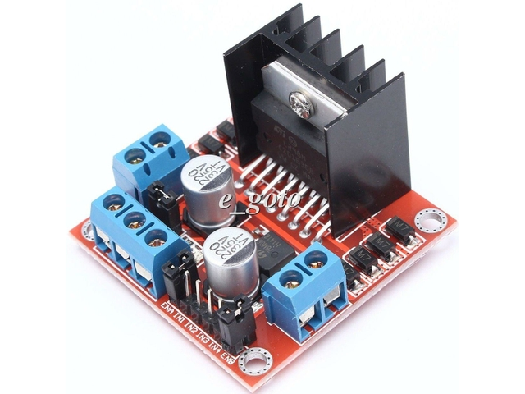

General Description
L298N is a kind of high voltage, high current motor driver chip produced by the ST company. It has a15 pin package, and a high working voltage (maximum voltage up to 46V), a large output current (instantaneous peak current up to 3A, continuous working current 2A) and 25W of rated power. Two built-in H bridges offer high voltage and large current while full bridge drivers can be used to drive DC motors and stepper motors, relay coils and so on. Using standard logic level signal control, it has two enable control ends. It permits or prohibits device having a logic power supply input without the impact of input signal, which enables the internal logic circuit part to work at low voltage. The chip can connect to an external detecting resistor to give variations to the control circuit. This chip can drive a stepping motor or four phase stepping motor, and two DC motors as well.

Key Features
$2.87

Pros
Cheap
Will probably be effective
High power delivery

Cons
Cheap
We would need to buy two

Specifications
Driving voltage: 5V — 35V
Driving current: 2A (MAX single bridge)

Logical voltage: 5V
Logical current: 0mA-36Ma

Maximum power: 25W
weight: 30g
Periphery dimension: 43*43*27mm

Additional Notes
No reviews.
…
Product description written in poor English-it’s possible that we misinterpreted some specs.

Full APA Citation
http://www.newegg.com/Product/Product.aspx?Item=9SIA7BF2YR6262&nm_mc=KNC-GoogleMKP-PC&cm_mmc=KNC-GoogleMKP-PC-_-pla-_-Gadgets-_-9SIA7BF2YR6262&gclid=Cj0KEQjwvo6wBRCG3Zv92ZSLlIYBEiQA5PLVAg6KwXcXjkqtODySMVrROJ65_aBlvrl7dg5hgUBasqcaAi208P8HAQ&gclsrc=aw.ds

